A. Lung disease. A pair of cases—Mrs Pink and Mr Blue.

Abbreviations and reference ranges.
a, arterial; CO₂, carbon dioxide; P, partial pressure (used of a gas in fluids); O₂, oxygen; S, saturation (%). Blood Hb: adult male 140-170 g/l, adult female 120-155 g/l. PaO₂: varies with age etc. Normally about 13 kPa (100 mmHg).

Mr Blue and Mrs Pink are seen on the same night at an emergency clinic. Both are 65 and both have respiratory difficulties.
Both patients complain of severe asthma and are treated with nebulised bronchodilator by inhalation. Both have had symptoms for about ten years and are markedly restricted in their daily activities by breathlessness. However, both have had increased cough and symptoms in the last week. Mr Blue has been 'unable to sleep for the last four nights' in spite of four-hourly nebulised bronchodilator and has clear sputum. Mrs Pink has a dry cough, her breathlessness is worse than usual and she feels that her general health is going downhill.

* what do you think is going on here--are these presentations consistent with asthma? Is a patient's formulation of their illness reliable?
Mr Blue has an arterial hemoglobin (Hb) saturation (Sa0₂) by fingertip pulse oximetry of 90% and Mrs Pink of 95%.

* the pulse oximeter uses the relative absorbance of two wavelengths of light by arterial blood to estimate Sa0₂. What value is expected in health? Why is Mr Blue's 'saturation' reduced, and what would be the effects of this? How would the interpretation of Sa0₂ be affected by anemia? By carbon monoxide exposure (smoker) or poisoning?

On examination Mr Blue is mildly centrally cyanosed while Mrs Pink is pink, but has a marked increase in resting respiratory rate and appears anxious. There is no chest dullness on percussion or fever to suggest chest infection.

* what is 'cyanosis' and what is it due to? What might cause cyanosis in the hands and feet (acrocyanosis, peripheral cyanosis)? In the lips and face ('central' cyanosis)? What does the presence of cyanosis imply about the level of hemoglobin?

Mr Blue complains of exhaustion with coughing and is sent to a hospital. Mrs Pink asks about a prescription for a mild relaxant (diazepam, a benzodiazepine) to ease her state.

* can you suggest a reason why Mrs Pink is so troubled by dyspnea when her oxyhemoglobin saturation is reasonable? Can you suggest why Mr Blue is not troubled by this in spite of a clearly reduced Sa0₂? Is there any reason not to help Mrs Pink as she requests by prescribing her a mild tranquilliser?

B. A Frightening Evening.

Abbreviations.
a, arterial; CO₂, carbon dioxide; HCO₃⁻ bicarbonate (ion); P, partial pressure (used of a gas in fluids).

A 19 year old male is brought to a doctor's office in Khandallah by his mother who is very worried. He was found shortly earlier in considerable distress complaining that he was unable to breathe. He is unable to provide a coherent history.
On examination his respiratory rate is markedly increased at rest to nearly 50/min at times. There is no cough. There is no cyanosis (blue tint of lips suggesting a high reduced hemoglobin level) or pallor (reduction in the red colour of the conjunctival mucosa suggesting anemia). He is diaphoretic (sweaty) but afebrile. He is able to speak in short sentences but seems anxious and only answers simple questions. He is making use of accessory respiratory muscles and his breaths are deep with marked chest wall movement. On auscultation of his chest there are prominent air sounds with no adventitiae (added sounds).

* what is a normal adult resting respiratory rate (from your own experience)? * is this asthma, or an airway problem generally? * what will be the effect of increased ventilation on the partial pressure of carbon dioxide in the arterial blood-an increased level (hypercapnia) or a decreased level (hypocapnia)?

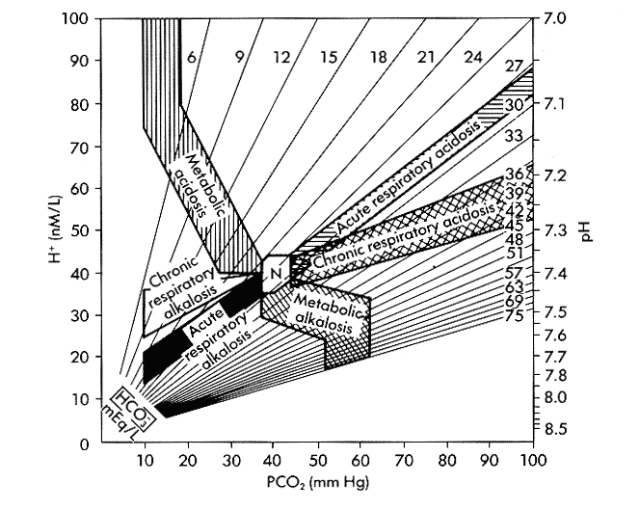

The diagram on the previous page is one way of laying out in a plane the three variables involved in acid-base balance in the blood (PaCO₂-the partial pressure of arterial CO₂, HCO₃⁻-the concentration of the bicarbonate ion, and pH, the degree of acidity or alkalinity of the blood). The pH can also be expressed as [H⁺], the concentration of hydrogen ions (protons). The figure shows that given any two of these three values the third is determined. Note that oxygen carriage is not directly related to acid-base status. This 'nomogram' is used for the interpretation of the results of arterial blood gas tests. The region labelled 'N' indicates normal acid-base values.

* If there is little change in [HC0₃⁻] so far in this patient, what is the effect of the change in PaCO₂ noted in the last question on the pH of the blood? What is the category of acid-base disturbance exhibited by this patient?

The patient between gasps says that he has cramping in the arms and tingling and numbness.

* an increase in blood pH (alkalosis) has some general (systemic) effects on the body, particularly on the musculoskeletal and nervous systems. Can you suggest ways in which this might occur?

Instructing the patient to reduce the rate and depth of breathing has no effect. A feedback loop is occuring, which is maintaining ventilation at abnormal values.

* a similar feedback loop can maintain disordered function in other systems. Can you give an example?

* bearing in mind that ventilation is controlled from the caudal brainstem (medulla oblongata) rather than by the lungs themselves, can you sketch a figure indicating the course of this circuit?

The young doctor does not recognise the syndrome and sends him off to a hospital. However, in the ambulance the experienced paramedics resolve his respiratory distress with a simple manouvre.

* what is the manouvre?

* how does it solve the problem?

* can you suggest other causes of "hyperventilation" besides the syndrome described here?

The mother quietly informs the doctor that there was a possible precipitating event involving a break-up with a girlfriend two days before.

* in what proportion of cases does the doctor ever find out what really went on?
_____________________________
The nomogram is from Goldberg, M, Green, SB, Moss, SL et al., 1973. JAMA 223:269.

This page and the other respiratory clinical problems are available with further information and links at http://www.health.auckland.ac.nz/physiology/neurophysiology/public/teaching/respiratory
_probs/default.html or at http://textbox.webhop.info/physiology_teaching/respiratory_physiology/cl
inical_problems. We suggest that you do not look at the demonstrators’ notes until after the class.

